The H2S BandMap ver3.50.335-47 all pictures are in original size.

1. General

Logger32 has function to receive and display deoded callsign with some informations on H2S BandMap . These data are distributed via UDP (User Datagram Protocol) at every about 15 seconds (FT8 Mode) or 60 seconds (JT65, JT9 Mode etc) by WSJT-X/JTDX program.
When QSO is logged in WSJT-X/JTDX then Logger32 log this QSO via UDP.

Note: When QSO is logged in JTDX then Logger32 log this QSO via TCP as well
Note: H2S BandMap and JTAlert program do not work at same time.

2. WSJT-X/JTDX settings
2.1 Settings in WSJT-X program

Look for UDP Server group. You should leave the default value like this.

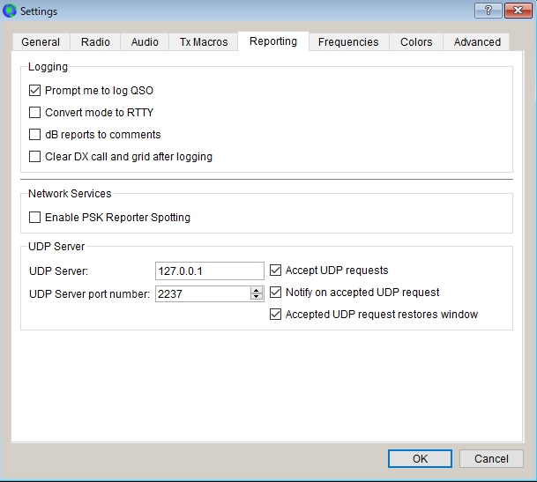

HBM_1

2.2 Settings in JTDX program

Look for UDP Server group. You should leave the default value like this.
If you do not use External logbook connection then uncheck "Enable data transfer to external log"
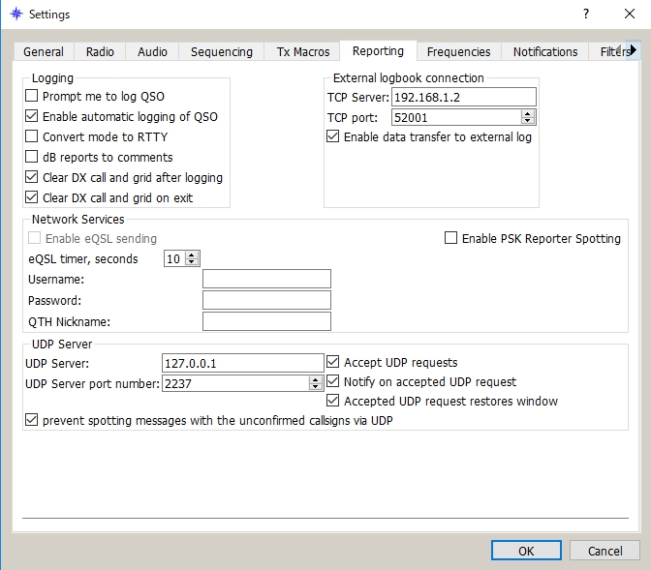

HBM_2

3. Logger32 settings
The callsign highlight colors and DXCC award tracking informations displayed in H2S BandMap depend on the settings in "DX Spot highlight color" and "Setup phone/digital modes"

Settings for me to operate FT8, JT9 and JT65 below.

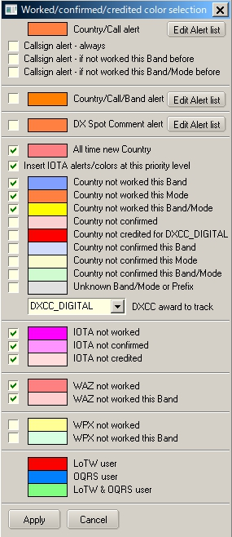

HBM_3

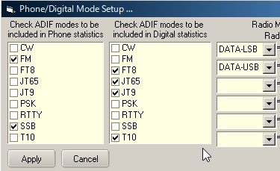

HBM_4
With this settings Worked/confirmed Window looks like below.

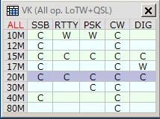

HBM_4A

4. Operation (1)
(a) Run WSJT-X or JTDX. Do not run JTAlert at same time.
(b) Run Logger32
(c) Right click on "H2S" in the lower status bar. Click "Open H2S BandMap"

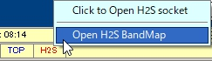

HBM_5

When WSJT-X or JTDX decode callsigns these callsigns are displayed in the H2S BandMap.
WSJT-X or JTDX, Band and Mode are displayed in title bar. Band and Mode are derived from WSJT-X or JTDX.
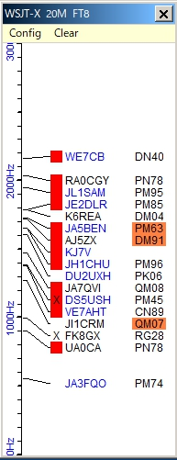

HBM_6

(d) Click "X" to close H2S BandMap.

5. Menu
5.1 Config
There are a lots of options. You may choose whatever you prefer now.
If you want to see highlight colors and tooltips informations based on every mode then un-check "Highlight callsigns as "DIG" mode" This option works for displaying "QSOd B4" mark as well.
If you want to use direct logging then check "Allow QSO automatic logging" If you want to see Gridsquare then check "Show Gridsquares"

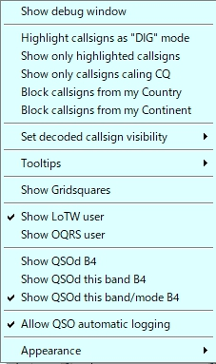

HBM_7

Sub menu for "Set decoded callsign visibility"

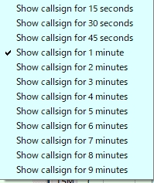

HBM_8

Sub menu for "Tooltips"

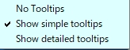

HBM_9

Sub menu for "Appearance"

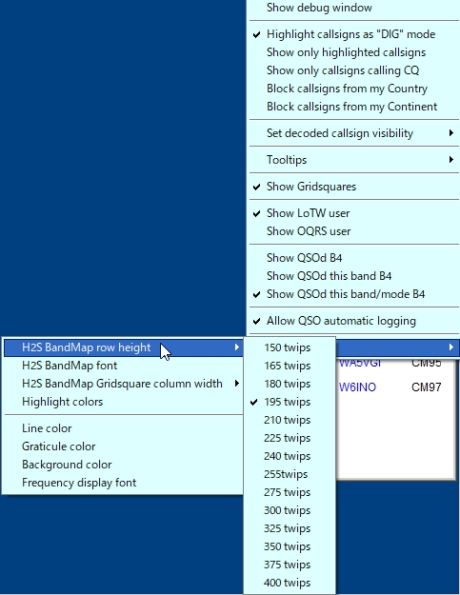

HBM_10
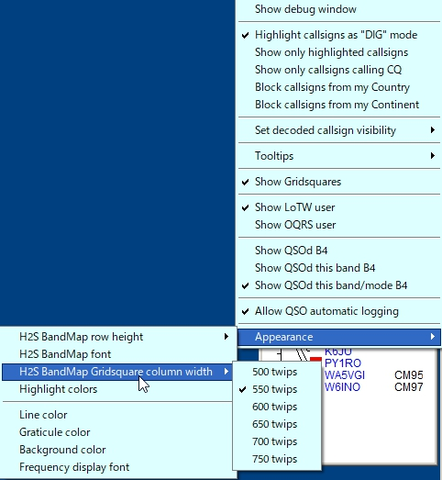

HBM_10A

Click "Highlight colors" to configure Gridsquare highlight colors and H2S BandMap text color. If you prefer to see bold text for CQing callsign then check "Show bold text when station CQing".

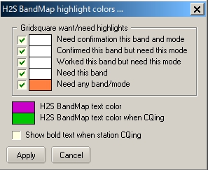

HBM_11

5.2. Clear
This clears H2S BandMap.

6. Operation (2)
(a) If you move mouse over callsihn then tooltips appears.

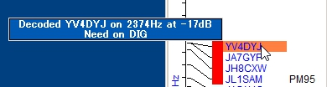

HBM_12

(b) If you left-click any callsign then this callsign is transferred in Logbook Entry Window.

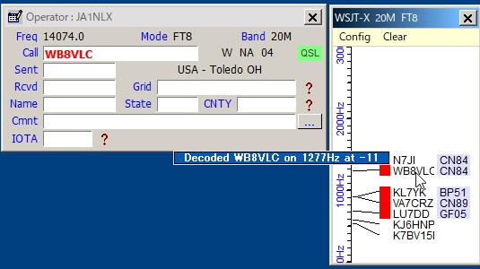

HBM_13

(c) If you right-click any callsign then history of this callsign is displayed. (max 15 messages)

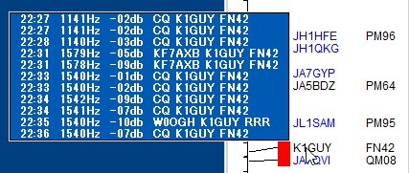

HBM_14

(d) If you confugure various options properly then you see LoTW/OQRS user, QSO B4, highlighted callsign and Gridsquare.

(e) When QSO is logged in WSJT-X/JTDX then Logger32 log this QSO via UDP if "Allow QSO automatic logging" is checked.

7. Tips
(a) If you have "Show only callsigns calling CQ" and "Show only highlighted callsigns" checked then the only station that are highlighted and calling CQ will show.
(b) The BLOCK COUNTRY and BLOCK CONTINENT options look for a Country/Continent match with the Logger32 Current Operator. If you have the Logger32 operator set to "At the Beach" or "Club Station" or something other than the callsign of where you are operation, the results will be unpredictable.

(c) Try to change settings of "DX Spot highlight colors" in DX Spot Window and settings of "Setup phone/digital modes" in Tools menu. It affects the way to display highlight colors and tooltips in H2S BandMap.

(d) Debug window is very useful to check problem. Click "Show debug window" in Config menu to show debug window.

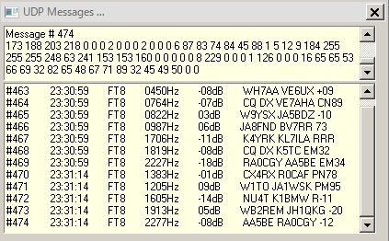

HBM_15

